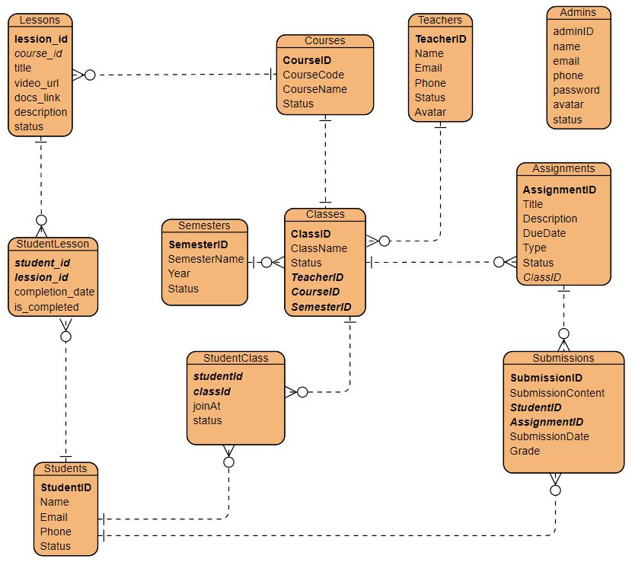

Cấu trúc JSP của tôi

* admin
  + …
  + lession
    - lession-form.jsp
    - list.jsp
* authen
  + - login.jsp
* common
* commonAdmin
* commonStudent
* commonTeacher
* dashboard
* homepage
* student
* teacher